image 190729 Rock Spring 150 ft AGL - 200228 ground control points

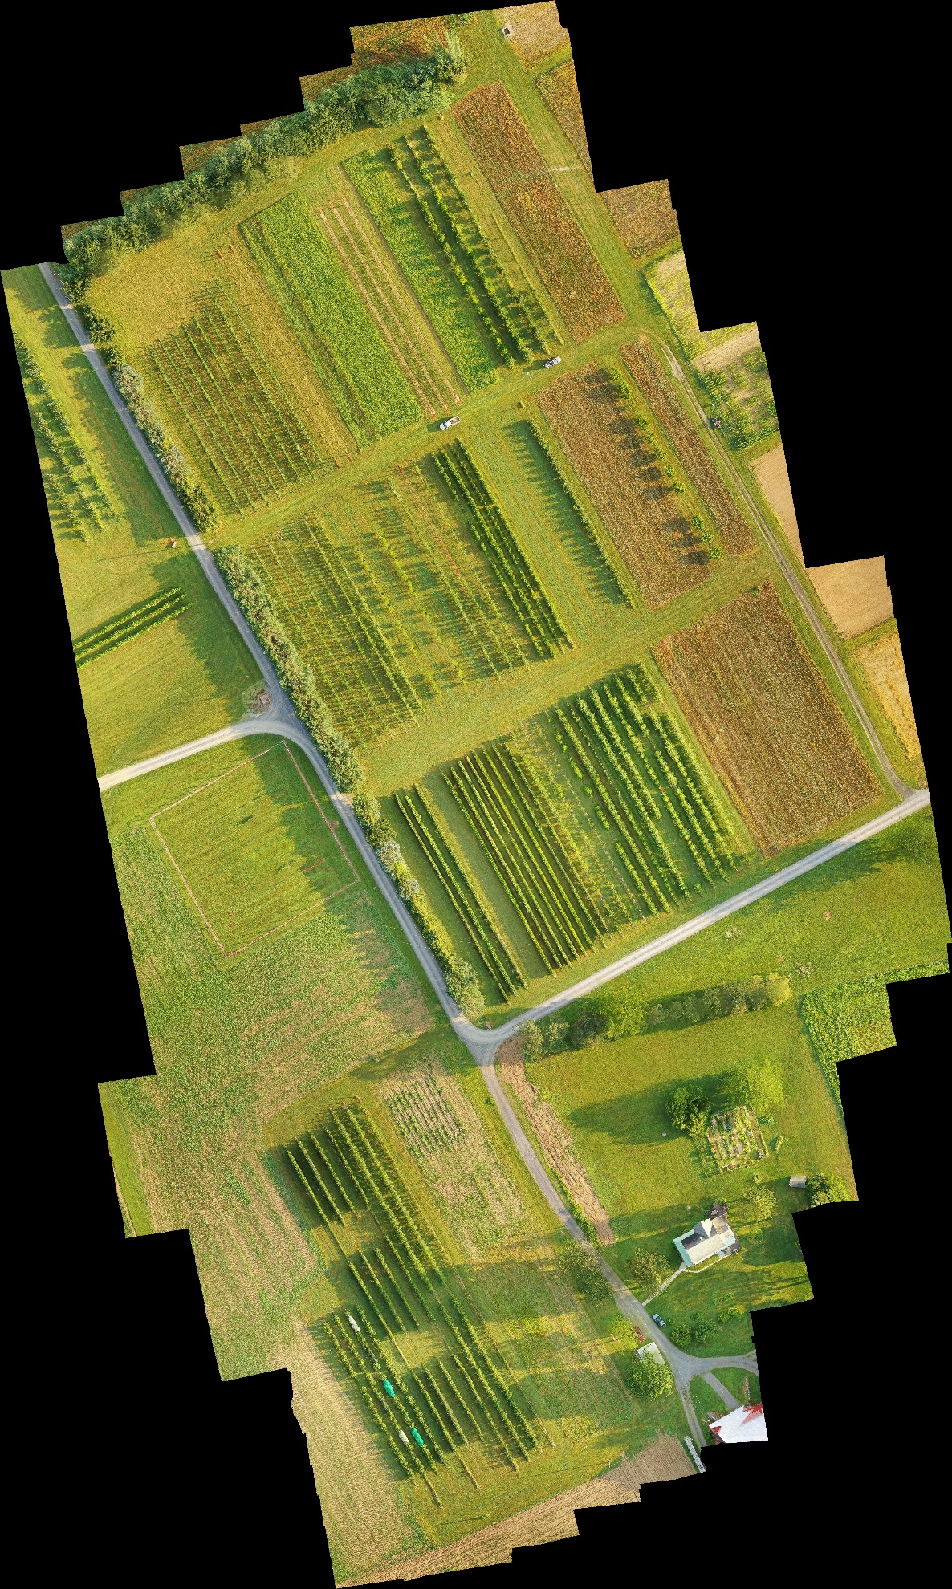

++++++++++++++++++++++++++++++++++++++++++++++++++++++++++++

200228 Brennan - 3 cm precision - lat-lon-ele [m]

A3 north 40.710134839739580 -77.955019166348350 337.8129193484783

A2-A3 40.709815901148290 -77.954123185527040 338.2796263080090

A1-A2 40.709106482766910 -77.953828621976260 338.113319743424

A1 south 40.708703612814260 -77.952881616390300 337.6167143518105

CW north 40.708099658813210 -77.954413132210600 339.1010537752882

D south 40.707060889035030 -77.954052891777240 341.1957845259458

++++++++++++++++++++++++++++++++++++++++++++++++++++++++++++

190607 iPhone - **approximate** lat-lon

A3 north 40.710129 -77.955052

A2-A3 40.709770 -77.954098

A1-A2 40.709273 -77.953852

A1 south 40.708667 -77.952962

CW north 40.708085 -77.954395

D south 40.707144 -77.954138

++++++++++++++++++++++++++++++++++++++++++++++++++++++++++++